 | 12.1.65 Editors - Geometry Nodes Editor - Header - Add Menu - Geometry Nodegroups - Hair - Utility
Table of content
Detailed table of content 1
Add menu - Hair - Utility 2
Attach Hair Curves to Surface 3
Redistribute Curve Points 4
Restore Curve Segment Length 4

Detailed table of content
Detailed table of content
Detailed table of content 1
Add menu - Hair - Utility 2
Attach Hair Curves to Surface 3
Input 3
Geometry 3
Surface Object 3
Surface 3
Surface UV Map 3
Surface Rest Position 3
Sample Attachment UV 3
Snap to Surface 3
Align to Surface Normal 3
Blend along Curve 3
Output 3
Geometry 3
Surface UV Coordinate 3
Surface Normal 3
Redistribute Curve Points 4
Input 4
Curves 4
Factor 4
Feature Awareness 4
Output 4
Curves 4
Restore Curve Segment Length 4
Input 4
Curves 4
Selection 4
Factor 4
Reference Position 4
Pin at Parameter 4
Output 4
Curves 4

Add menu - Hair - Utility

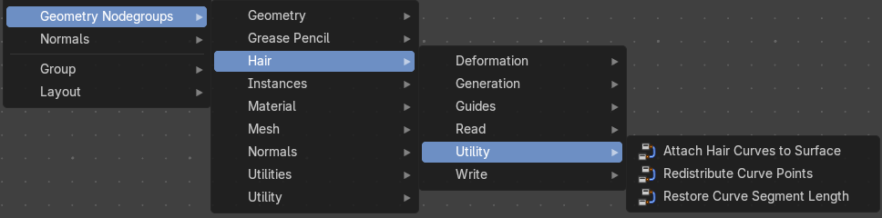
The nodes in this submenu are node groups. They use the regular single nodes under the hood.
It is virtually impossible to document these nodes in detail. So we will just list them.
When you double click the header, then you will enter the first level of the group. When you then press tab, or click again at the header, then you will reach the single nodes.




To leave the group you can use the breadcrumb up left in the header. These breadcrumbs are clickable. Or the Parent Node Tree button up right in the header.

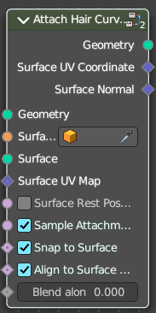
Attach Hair Curves to Surface
Attaches hair curves to a surface mesh.

Input

Geometry
The input geometry.

Surface Object
A surface object to attach to. It needs to have matching transforms.

Surface
Surface geometry to attach hair curves to.

Surface UV Map
Surface UV Map used to attach hairs to.

Surface Rest Position
Set the surface into rest position before attachment.

Sample Attachment UV
Sample the surface UV mapp at the attachment point.

Snap to Surface
Snap the root of the curve to the closest surface point.

Align to Surface Normal
Align the curves to surface normals. Needs a guide as reference.

Blend along Curve
Blend deformation along eacah curve from the root.

Output

Geometry
The output geometry.

Surface UV Coordinate
Surface UV Coordinate at the attachment point.

Surface Normal
Surface Normal at the attachment point.

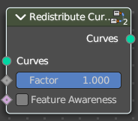
Redistribute Curve Points
Redistributes existing control points evenly along each curve.

Input

Curves
The input curve.

Factor
Factor to blend overall effect.

Feature Awareness
Use simple feature awareness to keep feature definition.

Output

Curves
The output curves.

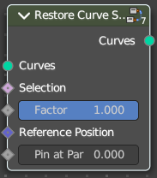
Restore Curve Segment Length

Input

Curves
The input curve.

Selection
A selection of the input curve.

Factor
Factor to blend overall effect.

Reference Position
Reference position before deformation.

Pin at Parameter
Pin each curve at a certain point for the operation.

Output

Curves
The output curves.

